Ajith Vijayan
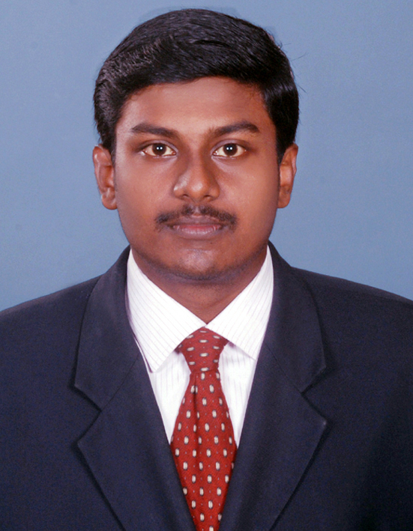
Vishnu Nivas
Thonnalloor Phone : 04734 254199
Pandalam (P.O) Mobile : +919539404236
Pathanamthitta-689501. getvishnuv1990@gmail.com

Career Objective
To work in a challenging, dynamic and responsible position in an organization calling for total dedication, creativity and decision making in order to combine the use of intellect and initiative so as to fully utilize the skills acquired there by achieving both organizational and career building goals.

EXPERIENCE

- Working as a Business Development Officer in Axis Bank Kottayam, from 25 July 2014 to
till date.

Educational qualifications

Course | College/ Institution | University | Year | Percentage
M.B.A  (Marketing&Finance ) | M.S.N.Institute.of  management &Technology. | Kerala University | 2012-14 | 66%
BBA | SAS SNDP Yogam College,  Pathanamthitta | Mahatma Gandhi University | 2008-11 | 59.4%
12th | P H S S Mezhuveli Kozhencherry | Board of higher secondary Examination, Kerala | 2006-08 | 51%
10th | N S S B H S Pandalam | Board of secondary examination,  Kerala | 2006 | 56%

Summer Internship - MBA

Summer Internship at COIRFED Alappuzha, for a period of 45 days 2nd May - June 15nd, 2014

Internship Project

Financial Performance Analysis of COIRFED

STRENGTHS
- Excellent communication and marketing skill
- High commitment to assignment
- Excellent interpersonal skills and decision making
- Problem solving skills.
- Flexible nature to adapt organizational change.

COMPUTER SKILLS
- MS Office, Tally 9.0

LANGUAGES KNOWN

English
Malayalam

Personal Data

- NAME : Ajith Vijayan
- DATE OF BIRTH : 07/09/1990
- SEX : Male
- FATHER’s NAME : Vijayan Pillai P N
- NATIONALITY : Indian
- HOBBIES : Listening Music, Driving
- ADDRESS : Same as above

REFERENCE

1)Mr.Sanoj Lal K S
Branch Sales Manger
Axis Bank Trivandrum
Mob:09744552209

2) Mrs.Biby P Joseph
Deputy Manager
Axis Bank Kottayam
Mob:09447114282

3) Mr.Biju Sebastian
Asst: Manager
Axis Bank Kottayam
Mob:9496323645

DECLARATION
I hereby declare that the above statements are true to the best of my knowledge.


Place : Pathanamthitta
Date:19/11/2015
Ajith Vijayan

